Cat B: OOPS

B1- Write an Arithmetic class that includes methods for operations such as addition, subtraction, multiplication, division, etc and test it.

Arithmetic.java-

**Code:**

class Arithmetic

{

public String add(double i, double j)

{

return("Addition of "+i+" and "+j+" is "+(i+j));

}

public String sub(double i, double j)

{

return("Subtraction of "+i+" and "+j+" is "+(i-j));

}

public String multi(double i, double j)

{

return("Multiplication of "+i+" and "+j+" is "+(i*j));

}

public String div(double i, double j)

{

return("Division of "+i+" and "+j+" is "+(i/j));

}

}

Test.java-

**Code:**

import java.util.Scanner;

class Test

{

public static void main(String[] args)

{

Scanner sc=new Scanner(System.in);

System.out.println("Enter the 1st number: ");

double i = sc.nextDouble();

System.out.println("Enter the 2nd number: ");

double j = sc.nextDouble();

sc.close();

Arithmetic a=new Arithmetic();

System.out.println(a.add(i,j));

System.out.println(a.sub(i,j));

System.out.println(a.multi(i,j));

System.out.println(a.div(i,j));

}

}

**Output:**

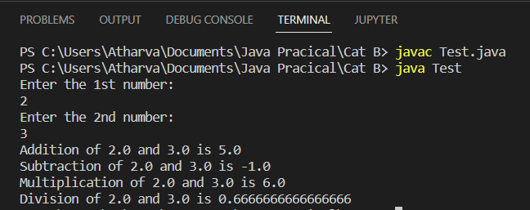

**B2-** Write a JAVA program to design a class Area for calculating area of rectangle. Use the concept of constructor. (default and parameterized constructor).

**Code:**

import java.util.Scanner;

class Area

{

double l, b;

Area()

{

l=25.3;

b=67;

}

Area(double l, double b)

{

this.l=l;

this.b=b;

}

public String calArea()

{

return("Area of rectangle with length= "+l+" and breadth= "+b+" is"+(l*b));

}

}

class RectArea

{

public static void main(String[] args)

{

Scanner sc = new Scanner(System.in);

System.out.println("Enter length: ");

double i=sc.nextDouble();

System.out.println("Enter breadth: ");

double j=sc.nextDouble();

sc.close();

Area a=new Area();

System.out.println("Default constructor: "+a.calArea());

a=new Area(i,j);

System.out.println("Parametrized constructor: "+a.calArea());

}

}

**Output:**

